**Mixins**

* A mixin is (just) a collection of methods
  + Less than a class: no instances of it
* Languages with mixins (e.g., Ruby modules) typically let a class have one superclass but include number of mixins
* Semantics: Including a mixin makes its methods part of the class
  + Extending or overriding in the order mixins are included in the class definition
  + More powerful than helper methods because mixin methods can access methods (and instance variables) on self not defined in the mixin

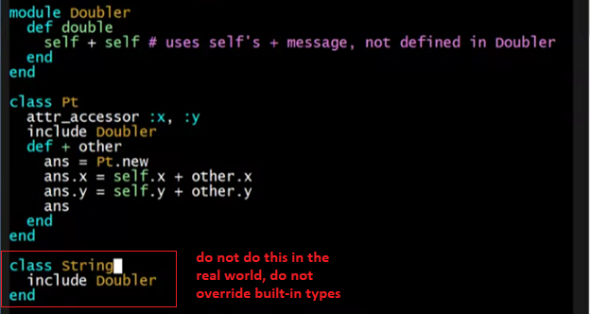

* **module** keyword
  + to define a mixin
* **include** keyword
  + to call the Doubler to be use the methods inside it
    - like interfaces/packages

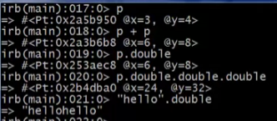

**Lookup rules**

Mixins change our lookup rules slightly:

* When looking for receiver obj’s method **m**, look in obj’s class, then mixins that class includes (later includes shadow), then obj’s superclass, then the superclass’ mixins, etc.
* As for instance variables, the mixin methods are included in the same object
  + So usually, bad style for mixin methods to use instance variables since a name clash would be like out *CowboyArtist* pocket problem (but sometimes unavoidable?)

**The two big ones**

The two most poular/usefule mixins in Ruby:

* Comparable: Defines <, >, ==, !=, >=, <= in terms of <=>

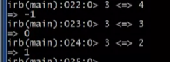

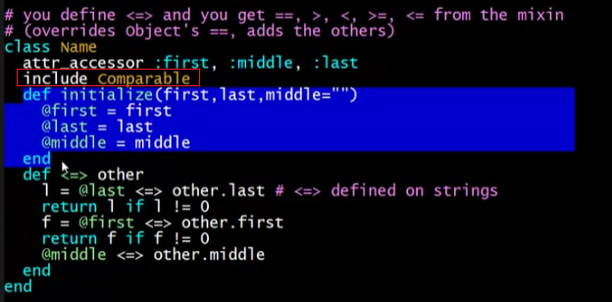

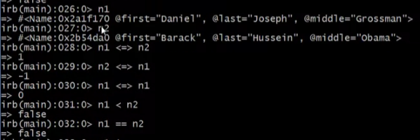

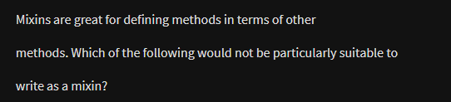

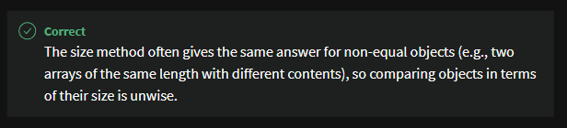

* **Enumerable**: Defines many iterators (e.g., map, find) in terms of each

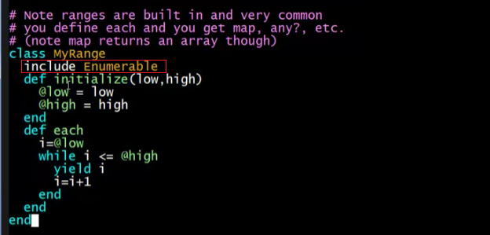

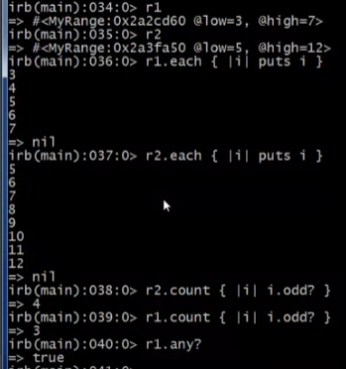

Great examples of using mixins:

* Classes including them get a bunch of methods for just a little work
* Classes do not “spend” their “one superclass” for this
* Do not need the complexity of multiple inheritance

**Replacement for multiple inheritance?**

* A mixin works pretty well for ColorPt3D:
  + Color a reasonable mixin except for using an instance variable

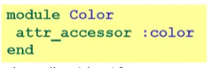

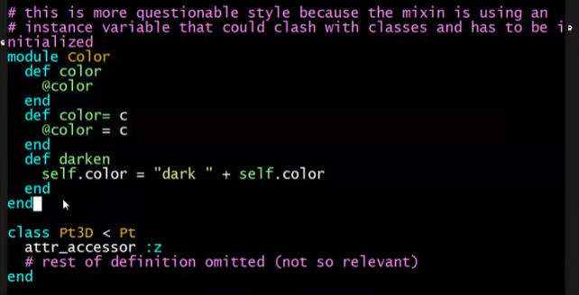

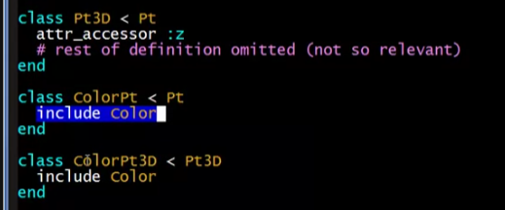

* A mixin works awkwardly-at-best for ArtistCowboy:
  + Natural for Artist and Cowboy to be Person subclasses
  + Could move methods of one to a mixin, but it is odd style and still does not get you two pockets

